- Static Block

package staticblock;

public class StaticBlock {

static void display()
{
System.out.println("DisplayFunction");
}
static{
System.out.println("StaticBlock");
}

public class Main {

public static void main(String[] args) {

System.out.println("Main Function");
StaticBlock.display();
}

}

Output:

Main Function
StaticBlock
DisplayFunction
BUILD SUCCESSFUL (total time: 0 seconds)

2.Static Block

package staticblock;

public class StaticBlock {

static void display()
{
System.out.println("DisplayFunction");
}
static{
System.out.println("StaticBlock");
}
public static void main(String[]args)
{
StaticBlock.display();
}
}

Output:

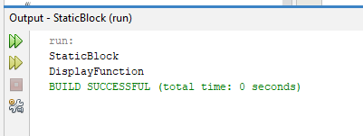

3.Vehicle

package vehicle;
public class Vehicle {
String color;
double weight;
Vehicle(String color,double weight)
{
this.color=color;
this.weight=weight;
}
void attribute()
{
System.out.print("color:"+color)
System.out.println("weight:"+weight);
}
}
package vehicle;
public class Car extends Vehicle {
int gear;
Car(String c,double w,int g)
{
super(c,w);
gear=g;
}
void Car_info()
{
super.attribute();
System.out.println("g");
}
}
public class Main {
public static void main(String[]args)
{
Car c = new Car("ab",112.34,10);
c.Car_info();
}
}

Output:
